CHILD FIND

Child Find is the process for identifying, locating and evaluating all children with disabilities, aged birth to 21, who are in need of early intervention or special education services.

Montesano School District provides developmental screenings year round to children between the ages of three and five to identify possible delays in language, motor, cognitive or social-emotional development. If you have questions or concerns about your preschooler's development, or to refer a child for evaluation, contact Child Find at the Student Services Office 360-249-1233.

Free Developmental Screenings will be offered in the fall for the 2022-2023 school year. Watch for dates in the local newspaper and the district website at www.monteschools.org

Additionally, IDEA requires that homeless preschoolers and all homeless children be included in the “Child Find” process for early identification of special education needs. If your family is living in a temporary situation, you may contact the district where you are currently staying for a screening.

CALL 360-249-1233 for questions or concerns.

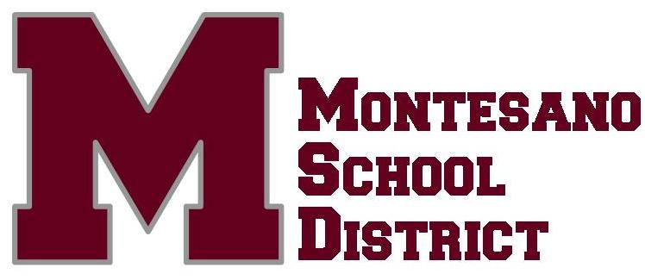
The Montesano School District No. 66 complies with all federal and state rules and regulations and provides equal access to all programs and activities without discrimination based on race, creed, religion, color, national origin, age, sex, sexual orientation including gender expression or identity, veteran or military status, marital status, presence of any sensory, mental, or physical disability, or the use of a trained dog guide or service animal by a person with a disability and provides equal access to designated youth groups listed under Title36 U.S.C.

Inquiries regarding compliance, appeal and/or grievance procedures may be directed to Montesano School District's Title IX/RCW 28A.640 Officer, Pam Banks at 502 E. Spruce Ave., Montesano, WA, (360) 249-3942, and/or Section 504/ADA Coordinator, Shawn Brown, at 502 E. Spruce Ave, Montesano, WA, (360) 249-1233.

Shawn Brown, Director
Montesano School District
Student Services
502 E. Spruce Ave
Montesano, WA 98563
360.249.1233
sbrown@monteschools.org

502 E.

